**Instructions for Updating the Assets in the Shoot ‘em Up**

Before you begin the update, take a moment to open the shmup and run it. Play through it to get a sense of how it works. To run the shmup, set the project in Unity, open the scene called *title_menu.unity* and hit the play button. The shmup runs best in standalone 1024x768 mode.

**Setup**

Whenever you are updating assets the first thing you must do is back up the current assets.

1. Navigate to the Unity project folder and open it.
2. Right click on the *Asset* folder and copy it
3. Right click in an empty space within the Unit project folder and click paste
4. This creates a duplicate of the Asset folder that Unity will ignore but you can use later to fix any issues. You may choose to rename it. I usually call my backups *filename_bu01*



**Image Assets**

All of the graphic assets for the shmup are located in the Project folder under *Assets/Resources/Textures*. The image assets you will be replacing are as follows:

* Sprite Sheet: *anim_spritesheet.png* - *PNG - 2048x2048*
* Explosion particle:
* Loopable background: *bg.png* - 1024x1024 - PNG
* Loopable parallax layer 1: *parallax01.png* - 1024x1024 - PNG
* Loopable parallax layer 2: *parallax02.bg* - 1024x1024 - PNG
* 2 Menu screens (on one sheet): *UI_menu_screens.png* - 1024x2048 - PNG
* 5 buttons w/ up and over states: *(refer to image below for names) -* 128x64 - PNG

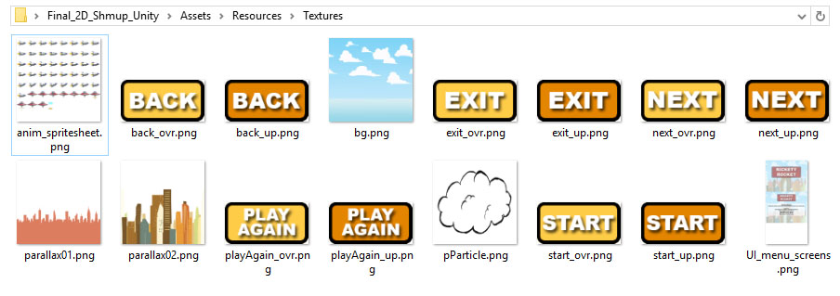

***Swapping Graphic Files***

If all of the images formats, pixel dimensions and file names match, updating the graphic assets is relatively easy.

1. Open the *Assets/Resources/Textures* folder
2. Drag and drop your new graphic assets into the *Assets/Resources/Textures* folder
3. Look in the folder and make sure everything updates
   1. if some of the files are not replaced, you probably need to check your file names and image formats
4. Go to unity and test the shmup

***Notes on updating graphic files:***

***Updating the Sprite Sheet***

Of all the graphic assets, the sprite sheet, which contains player, enemy and bullets, is the easiest to change.

The player, enemy and bullets should all be updated with your new graphics.

There are, however, a couple of tweaks you *may* need to make before it is complete.

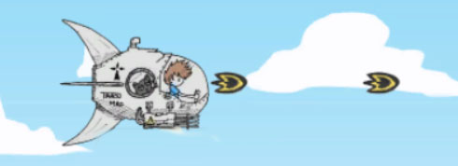

**bullet**

**gun**

Depending on the position of your gun on your *player avatar* and your *enemy avatar*, the bullets may be shooting from an odd place. To fix this do the following

*Player sprite*

1. Open the Stage1.unity scene file
2. In the hierarchy view, open the GameObject labeled *4 – player* by clicking on the arrow to the left of the name.
3. Continue opening the hierarchy until you get to *Player_Sprite*

**

1. Select *Player_sprite* in the hierarchy view
2. In the Scene View hit the [W] key to activate move mode
3. Move the *Player_sprite* until it lines up with the player bullet (you may have to run the game and then tweak a few times)

*Enemy sprite*

1. In the inspector window open up the *3 – Enemy* GameObject. You will find all of the enemy instances here.
2. In the hierarchy, open an enemy instance that is visible in the scene view. You will see an object called *WeaponObject*. This is what you will reposition for the gun.

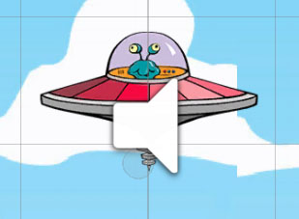

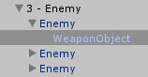

**WeaponObject (blue circle)**

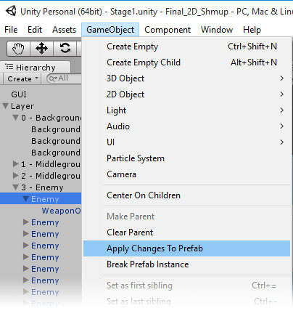

|  |  |
| --- | --- |
| 1. Select the *GameObject* and, using the transforms in the Inspector window move it to the correct position in relationship to the enemy ships gun   *IMPORTANT: You need to apply this edit to the rest of the ships*   1. Select the enemy ship again then click on GameObject > Apply Changes to Prefab this will update the prefab as well as all enemy instances |  |

***Updating the Background & Parallax Layers***

If everything is correct the background and parallax layers should line up appropriately. The only thing you may need to do is adjust the height of each element. Adjust it by changing the Y value on each element. Remember each layer has three instances of the layer sprite (for example: Background1, Background2, Background3). You need to adjust the Y position on each, the same amount.

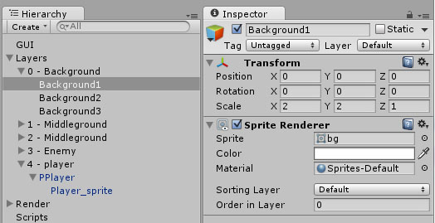

**Updating the Explosion Particle**

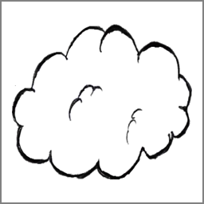 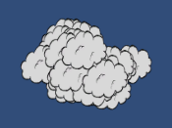

The explosion particle texture is used in a particle system called *pSmokeParticle.* This prefab uses the *pParticle.png* texture. As long as the pixel dimensions and your naming on the new PNG matches you should be able to simply swap it in the *Textures* folder. If something doesn’t work try following the instructions below.

1. In Unity, click on the *Assets/Resources/Prefab* folder in the *Project* tab
2. Inside the *Assets/Resources/Prefab* folder you will see a prefab called pSmokeParticle, select it
3. In the *Inspector* tab, all the way down at the bottom you will see a *shader component* that looks like this. This is what we need to change

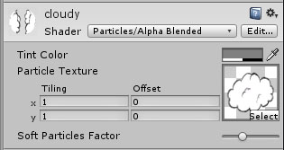

1. Now, back in the *Project* tab click on the *Assets/Resources/Textures* folder so you can see your textures to the right. **DO NOT select any textures** this will change the *Inspector* tab and you will have to go back and re-select the *particle prefab.*

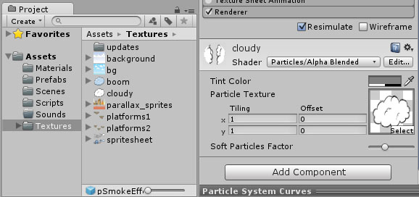

1. Now simply right click and drag your new particle (the 256x256 image you created) into the image preview on the *shader component*.

You should now have your own custom shmup level. It probably needs some tweaking but we will discuss that in the next couple classes. You have completed Project02c. Zip up your Unity project folder, name it appropriately and upload it to the P2c dropbox folder.

***Swapping Audio Files***

The audio files, that need to be replaced, can be found in the project folder under *Assets/Resources/Audio.*

* The looping music is in the Music Tracks folder called *GameTheme_SND.mp3*
* Sound effects are in the SFX folder
  + *EnemyShot_SND.mp3*
  + *Explosion_SND.mp3*
  + *PlayerShot_SND.mp3*

The length of the audio files does not matter but make sure the names and file formats are the same.